**SUMMER TRAINING REPORT**

ON

**"STUDENT INFORMATION CHATBOT"**

SUBMITTED IN PARTIAL FULFILLMENT OF THE REQUIREMENT FOR THE AWARD

OF THE DEGREE OF

**BACHELOR OF ENGINEERING**

**IN**

**Computer Science & Engineering**



**SUBMITTED BY:**

NAME : **AJIT KUMAR SINGH**

UNIVERSITY UID : **20BCS5501**

DEPARTMENT OF COMPUTER SCIENCE & ENGINEERING

CHANDIGARH UNIVERSITY GHARUAN, MOHALI

**CONTENTS**

1.Certificate 2-3

2. Declaration 3

3. Abstract 3

4. Acknowledge 3

5.Introduction 4

6. Software and hardware used 4-6

7. Design and interfaces 6-11

**CERTIFICATE**

I “AJIT KUMAR SINGH” hereby declare that I have undertaken Summer Training and developed project titled STUDENT INFORMATION CHATBOT during a period from 14 JUNE to 14 JULY in partial fulfillment of requirements for the award of degree of B.E (COMPUTER SCIENCE & ENGINEERING) at CHANDIGARH UNIVERSITY GHARUAN, MOHALI. The work which is being presented in the training report submitted to Department of Computer Science & Engineering at CHANDIGARH UNIVERSITY GHARUAN, MOHALI is an authentic record of training work.

AJIT

Signature of the Student

The training Viva–Voce Examination of__________________ has been held on ____________ and accepted.

 Signature of Internal Examiner Signature of External Examiner

**DECLARATION**

We, student of Bachelor of Engineering in Computer Science & Engineering , Summer training, Chandigarh University, hereby declare that the work presented in this Project Report entitled “STUDENT INFORMATION CHATBOT ” is the outcome of our own work, is bona fide and correct to the best of our knowledge and this work has been carried out taking care of Engineering Ethics. The work presented does not infringe any patent work and has not been submitted to any other university or anywhere else for the award of any degree or any professional diploma.

**ABSTRACT**

In this project, we are developing a chat bot which will provide result to the user’s queries about the students of our college and the college itself, hence the name “Student Information Chatbot ”, The user will be able to ask various questions to the chat bot about the college and students, the questions may be concerned with the infrastructure, accreditation, Training & Placements, Result etc. and also the chatbot can be used by thecollege faculties to ask specific information about the students, and the chat bot will be able to provide answer to the user’s queries.

**ACKNOWLEDGEMENT**

We would like to express our deep and sincere gratitude to our Project In charge **TAJINDER KAUR** for giving us the opportunity to do the project and providing valuable guidance throughout this research. Their dynamism, vision and exquisite efforts have deeply inspired us. They taught us the methodology to carry out the research and to present the research work as clearly as possible. It was a great privilege for us to study and work under their guidance.

We owe the completion of my project to our project Mentor for her continuous support and guidance.

**INTRODUCTION**

User interfaces for software applications can come in a variety of formats, ranging from command-line, graphical, web application, and even voice. While the most popular user interfaces include graphical and web-based applications, occasionally the need arises for an alternative interface. Whether due to multi-threaded complexity, concurrent connectivity, or details surrounding execution of the service, a chat bot based interface may suit the need.

Chat bots typically provide a text-based user interface, allowing the user to type commands and receive text as well as text to speech response. Chat bots are usually a stateful services, remembering previous commands (and perhaps even conversation) in order to provide functionality. When chat bot technology is integrated with popular web services it can be utilized securely by an even larger audience.

* A Student Information Chat Bot project is built using data base that analyzes user’s queries and understand user’s message.
* This System is a web application which provides answer to the query of the student very effectively.
* Students just have to query through the bot which is used for chatting.
* Students can chat using any format, as there is no specific format that the user has to follow.
* The System uses built in data base to answer the query.
* The answers are appropriate what the user queries.
* If the answer found to be invalid, user just need to select the invalid answer button which will notify the admin about the incorrect answer.

**Software and Hardware tools required for Project**

**Software:**

* **HTML**

HTML stands for Hyper Text Markup Language. Itis the standard markup language for creating Web pages. It describes the structure of a Web page.It consists of a series of elements. HTML elements tell the browser how to display the content.HTML elements label pieces of content such as "this is a heading", "this is a paragraph", "this is a link", etc.

Hypertext Markup Language (HTML) is the standard markup language for documents designed to be displayed in a web browser. It can be assisted by technologies such as Cascading Style Sheets (CSS) and scripting languages such as JavaScript.

* **CSS**

CSS stands for Cascading Style Sheets. CSS describes how HTML elements are to be displayed on screen, paper, or in other media. CSS saves a lot of work. It can control the layout of multiple web pages all at once. External stylesheets are stored in CSS files

* **JAVASCRIPT**

JavaScript often abbreviated as JS, is a programming language that conforms to the ECMAScript specification. JavaScript is high-level, often just-in-time compiled, and multi paradigm. It has curly-bracket syntax, dynamic typing, prototype-based object-orientation, and first-class functions.

Alongside HTML and CSS, JavaScript is one of the core technologies of the World Wide Web. JavaScript enables interactive web pages and is an essential part of web applications. The vast majority of websites use it for client-side page behavior, and all major web browsers have a dedicated JavaScript engine to execute it.

* **PHP**

PHP is a general-purpose scripting language that is especially suited to web development. It was originally created by Danish-Canadian programmer Rasmus Lerdorf in 1994; the PHP reference implementation is now produced by The PHP Group. PHP originally stood for Personal Home Page,but it now stands for the recursive initialism PHP: Hypertext Preprocessor.

* **MY SQL**

SQL is a standard language for accessing and manipulating databases. SQL stands for Structured Query Language. SQL lets you access and manipulate databases. SQL became a standard of the American National Standards Institute (ANSI) in 1986, and of the International Organization for Standardization (ISO) in 1987 .SQL can execute queries against a database, retrieve data, insert records in a database, update records ,delete records, create new databases, create new tables in a database, create stored procedures in a database, create views in a database, set permissions on tables, procedures, and views

**Hardware**:

* Processor (CPU) with 2 gigahertz (GHz) frequency or above
* A minimum of 2 GB of RAM
* Monitor Resolution 1024 X 768 or higher
* A minimum of 20 GB of available space on the hard disk .Internet Connection
* Broadband (high-speed) Internet connection with a speed of 1 Mbps.
* Keyboard and a Microsoft Mouse or some other compatible pointing device.

**Advantages:**

• User does not have to go personally to college office for the enquiry.

• The chat-bot will be very helpful to new students.

• This application enables the students to be updated with college cultural activities.

• This application saves time for the student as well as teaching and non-teaching

staff

**DESIGN & INTERFACE**

**WEBSITE HOME PAGE:**

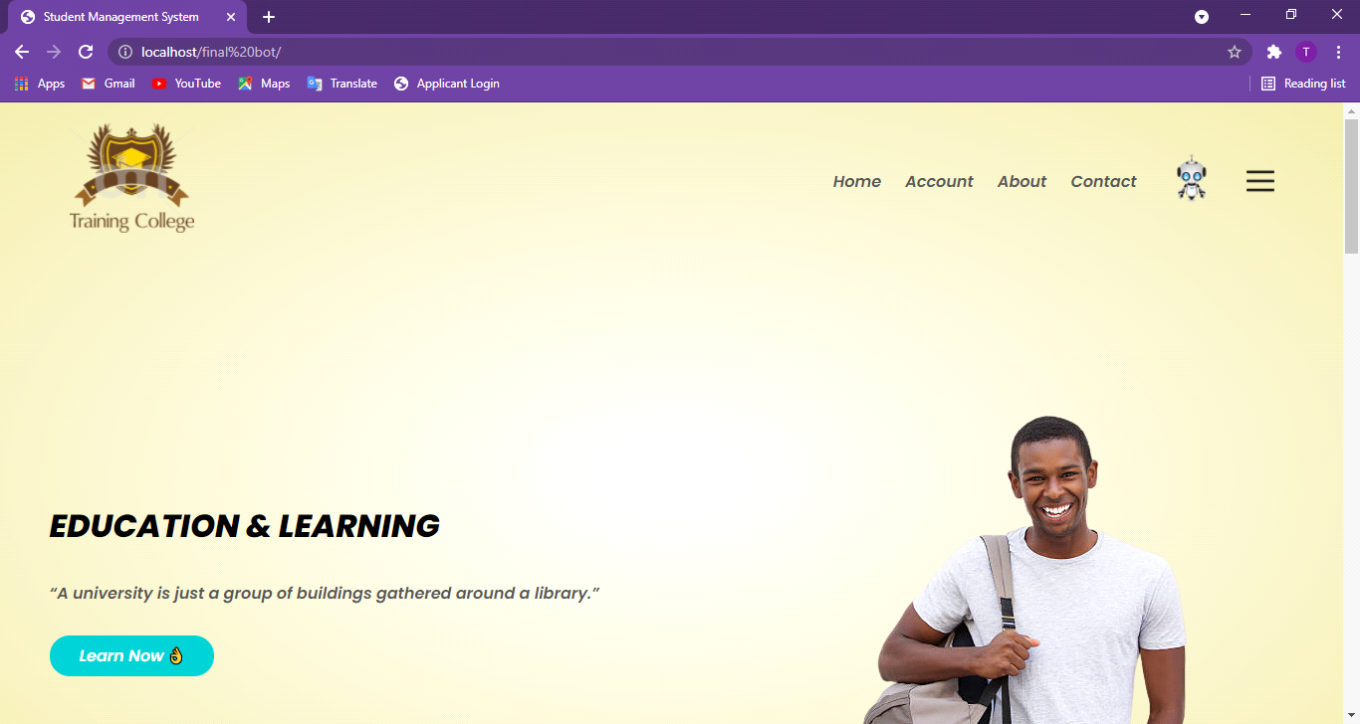

**User Interface**: The User Interface of the Chat-Bot is designed by using HTML and Cascading Style Sheets, and is capable of running on any window/display size computer or mobile devices.

The users can interact with the Chat-Bot by typing their queries in the textbox. And the Chat-Bot will provide a response to the user.

**CHATBOT INTERFACE:**

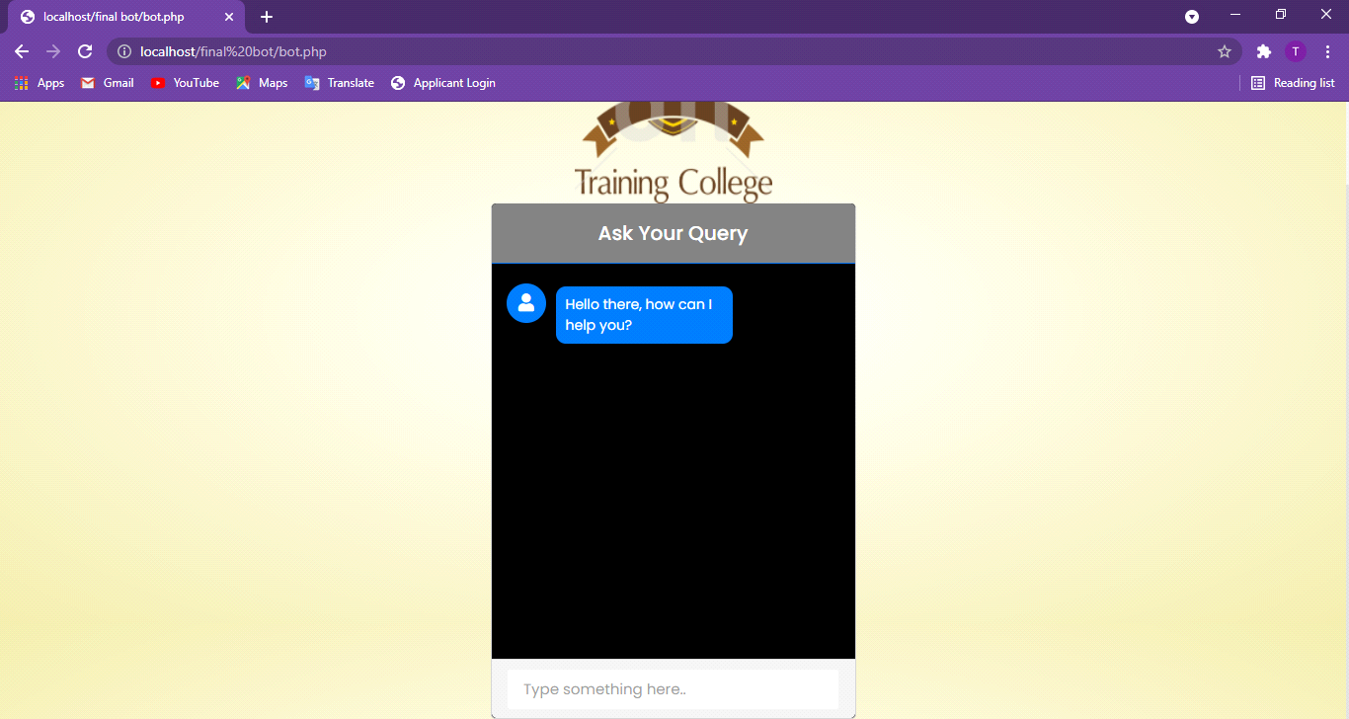

**APPLICATIONS**

* Chat Bot Information System can be used in colleges and it can be used in various firms to provide ease to users in conducting enquires.
* The chat-bot can be used by fresher students to know more about their college.
* The chat-bot can be used by the students to know about the Exam Time Table,Syllabus etc.
* This application enables the students to be updated with college activities
* The cat-bot can be used by the Faculties to get information about the students.
* Specific queries like the student’s email, phone no, address can be asked from the chatbot.

**RESULTS AND SNAPSHOTS**

Therefore, after implementing all the mentioned libraries as well as software tools, we finally full-fledge website with chatbot .







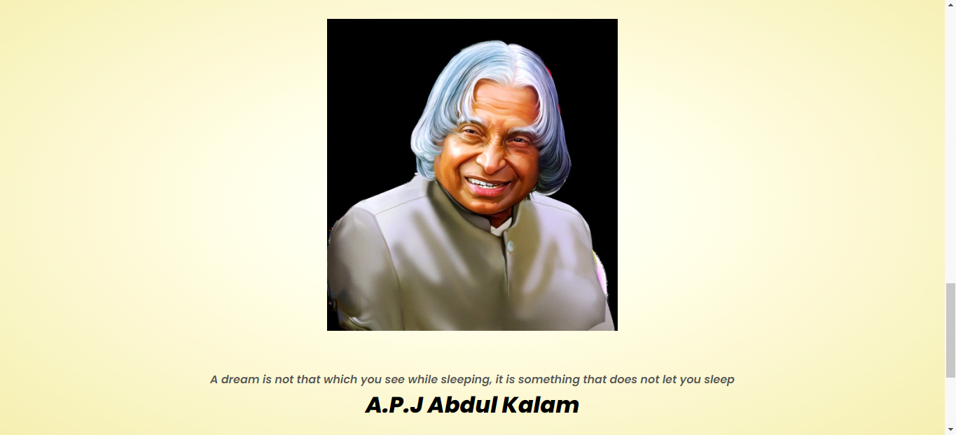

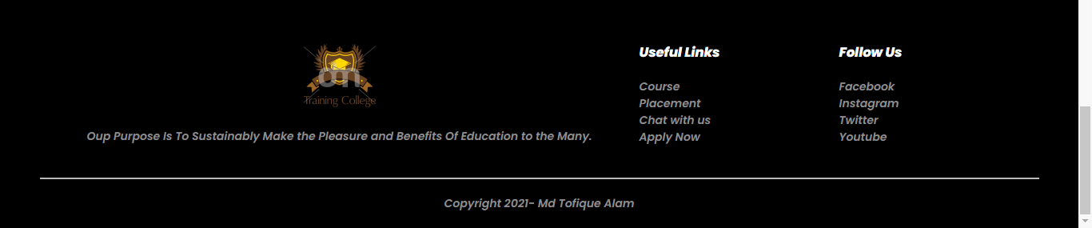

**Datebase Result Snapshot**

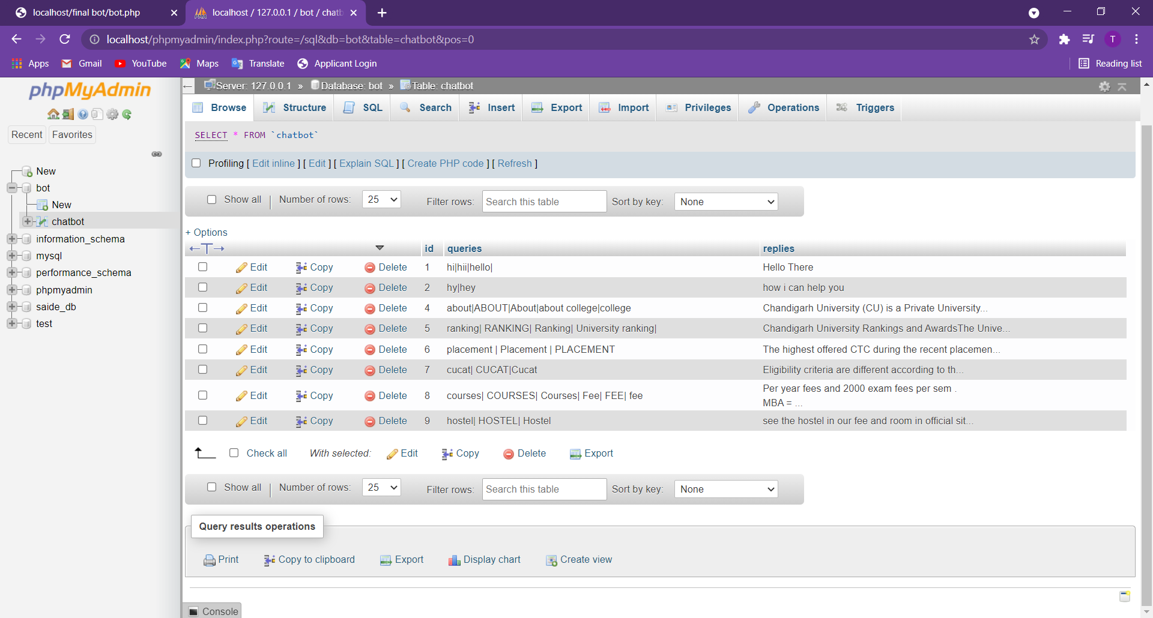

**Working of Chatbot**

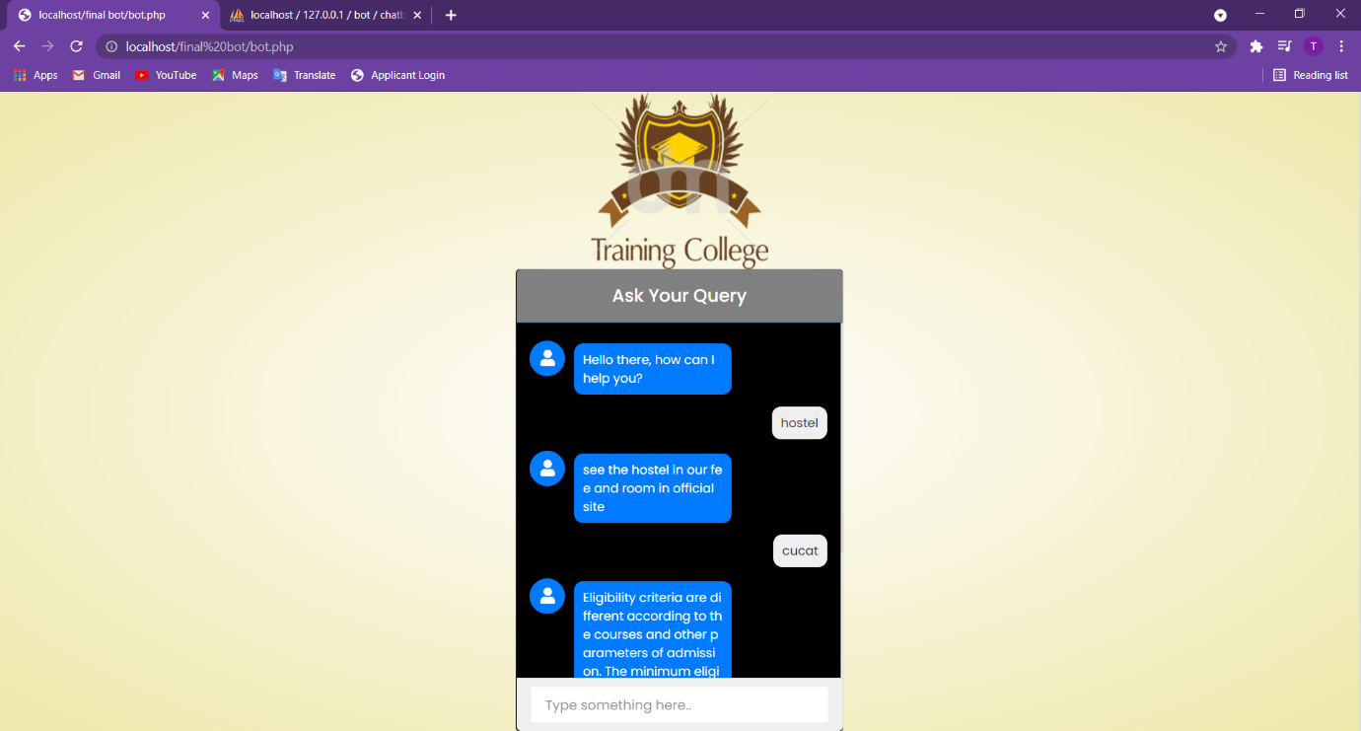

**CODE**

Code of website

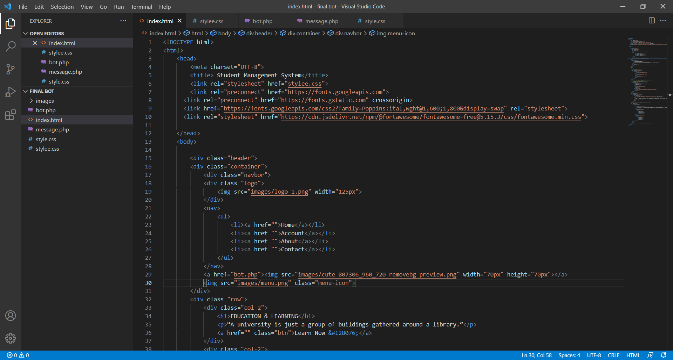

Code of Chatbot

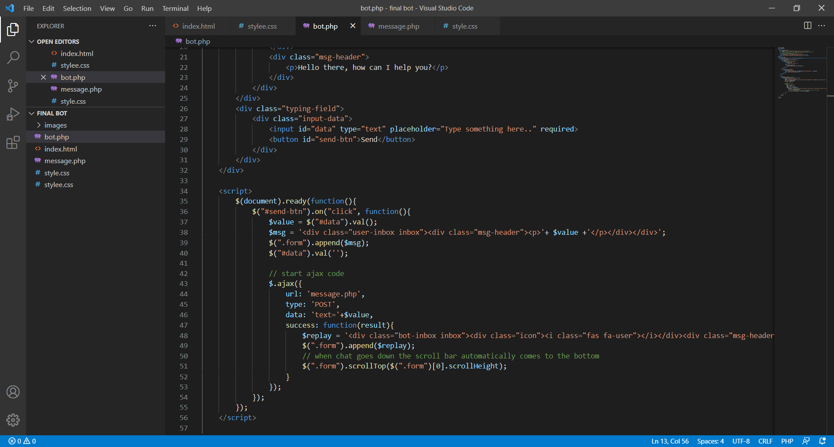

**REFERENCE**

For image: Google Image

For making website: We3school , Google

For chatbot:We3school,Google,Youtube